**LIBRARY MANAGEMENT SYSTEM**

**Introduction**

**Welcome to the Book Nest – Library Management System**, a dynamic, web-based solution designed to streamline the experience of managing and accessing library services. This platform bridges the gap between traditional library workflows and modern user expectations, offering both **members** and **administrators** a smooth, secure, and interactive interface.

Whether it’s **borrowing a book**, **donating titles**, **tracking fines**, or **resolving service issues**, Book Nest simplifies operations and enhances accessibility. With a focus on **usability, real-time interaction, and scalability**, this system empowers libraries to operate efficiently and users to engage effortlessly.

**Table Of Contents**

1. **Project Overview**
   * Purpose & Scope
   * User Roles: Member, Admin
   * Tech Stack Summary
2. **Member Pages**
   * **index.html** – Homepage
     + Links to login & registration
   * **member_registration.html** – Member Registration
     + New user sign-up with validation
   * **login.html** – Member Login
     + Credential login form
   * **member_home.html** – Member Dashboard
     + Summary of user activity & quick actions
   * **search_books.html** – Search Books
     + Filter by title, author, category
   * **borrowbook.html** – Borrow Books
     + Borrow interface with modal confirmation
   * **borrow_return.html** – Borrow/Return History
     + View history, renew, download receipt, export PDF
   * **donate.html** – Donate Books
     + Submit book details & track donation status
   * **member_complaints.html** – Register Complaint
     + Submit service or book-related complaints
   * **update_profile.html** – Update Profile
     + Edit personal/member details
   * **fine_payments.html** *(assumed)* – Pay Fines
     + Secure payment for overdue books
3. **Admin Pages**
   * **admin_login.html / admin_page.html** – Admin Login
     + Secure access for admin users
   * **admin_home.html** – Admin Dashboard *(assumed)*
     + View reports, manage library operations
   * **manage_books.html** – Manage Books
     + Add, update, search, or delete books
   * **search_members.html** – Manage Members
     + Search and manage user records
   * **manage_donations.html** – Handle Donations
     + Approve/reject member-donated books
   * **manage_complaints.html** – Handle Complaints
     + Resolve user-raised issues
   * **reports.html** – Reports & Analytics
     + Visualize library usage and statistics

# index.html

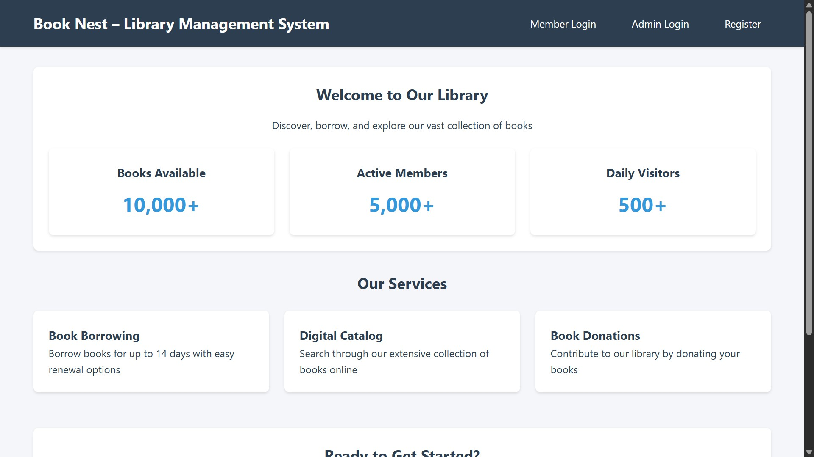

## Purpose:

This is the **landing page** of the Library Management System, titled **Book Nest**. It serves as the entry point for users to understand the services provided and to navigate to login or registration.

# Description:

* + Provides a welcoming interface with library stats (Books Available, Active Members, Daily Visitors).
  + Highlights core services like **Book Borrowing**, **Digital Catalog**, and **Book Donations**.
  + Offers navigation links to:
* Member Login
* Admin Login
* Member Registration
  + Concludes with a call-to-action encouraging new users to register.

# Functional Elements and Actions:

## Member Login (pages/login.html)

→ Redirects users to the member login page.

## Admin Login (pages/admin_login.html)

→ Redirects administrators to their login page for system management.

## Register (pages/member_registration.html)

→ Navigates to the registration form for new users to create a library account.

## “Register Now” Button

→ Also links to the member registration page to encourage sign-ups.

# Summary:

This homepage functions as a clean, user-friendly dashboard to inform and guide users into the system, allowing them to **login, register, or explore library services**.

—

# member_registration.html

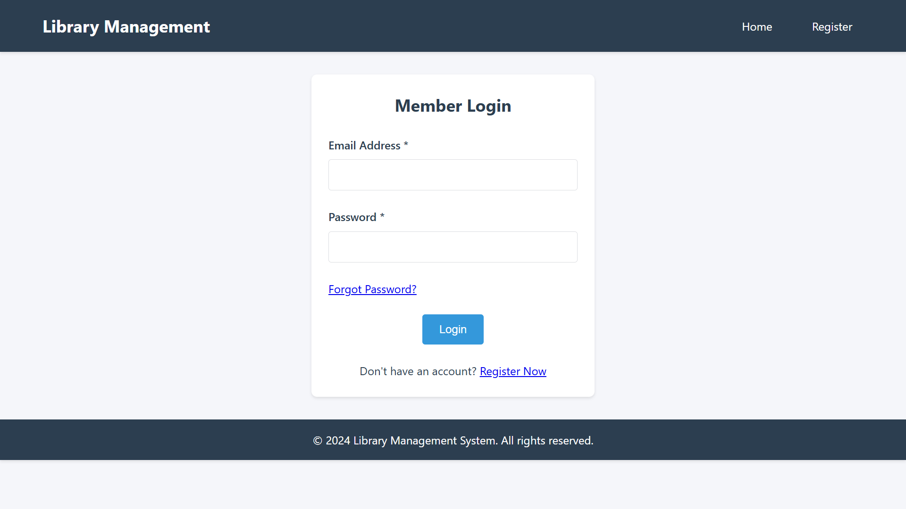

## Purpose:

This page provides a comprehensive **registration form** for new users to create a member account in the library system.

# Description:

* + Collects essential user data:

## Full Name, Email, Mobile Number

* **Address** (Line 1 & 2, City, State, PIN Code)

## Date of Birth

* **Password & Confirm Password**
* **Security Question & Answer** (for future recovery)
  + Navigation links are included for:
* Returning to **Home**
* Redirecting to the **Login** page
  + Input validations are handled using:
* HTML pattern attributes for client-side validation
* JavaScript for custom logic like:
  + Ensuring the user is at least **14 years old**
  + Confirming **passwords match**

# Functional Elements and Actions:

## Form Submission (id="registrationForm")

* Method: POST (action placeholder #)
* JS prevents default submission and validates:
  + Minimum age (14+)
  + Password and Confirm Password match
* On success:
  + Displays a success alert
  + Redirects to login.html

## Password Rules:

* Minimum 8 characters
* At least one uppercase, lowercase, digit, and special character

## Address Inputs:

* Split into multiple fields for structured data entry
* PIN code restricted to 6 digits

## Reset Button:

* Clears all form inputs

# Summary:

This page enables new users to securely register by entering valid and verified personal information. It ensures quality data through HTML patterns and JavaScript validations. Successful registration results in user redirection to the login page with an alert.

—

# member_login.html

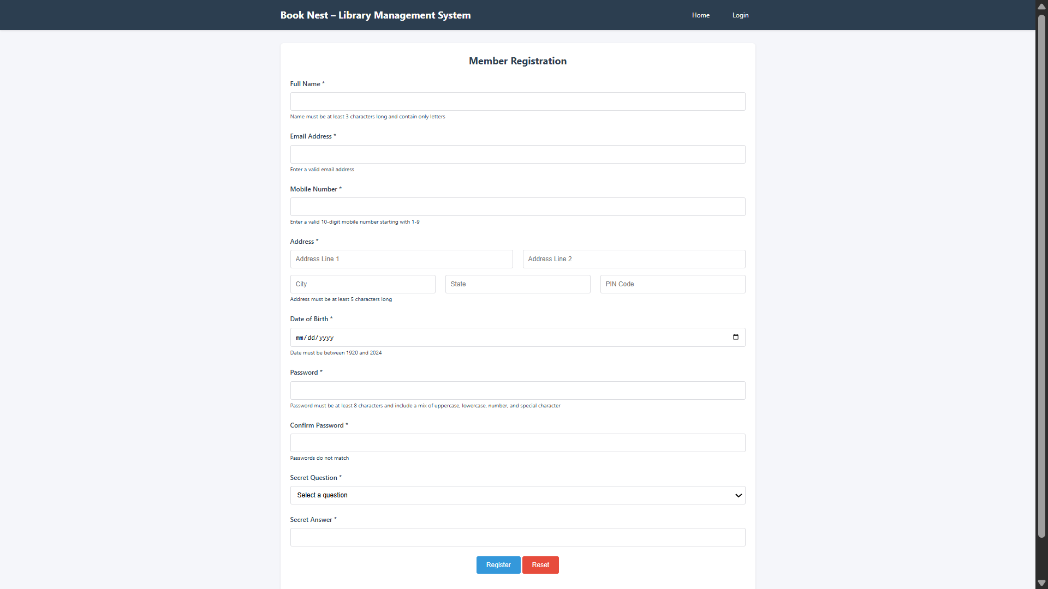

## Purpose:

This page provides a **secure login interface** for library members to access their personal dashboards and library services.

# Description:

* + Contains a login form with two required fields:
* **Email Address** (validated using regex for standard email format)

## Password

* + Navigation links are available to:
* Return to **Home**
* Go to **Registration** page
  + A placeholder alert section (#errorMessage) exists to display login errors (e.g., invalid credentials).
  + Includes a "Forgot Password?" link for recovery support (non-functional placeholder).
  + A registration prompt is shown for users without an account.

# Functional Elements and Actions:

## Login Form Submission (id="loginForm")

* Method: POST (action currently set to #)
* JavaScript (login.js) is expected to handle:
  + Field validation
  + Server request for credential verification
  + Display of error messages if login fails
  + Redirection to the dashboard upon successful login

## Forgot Password Link

* Currently non-functional; can be extended to redirect users to a recovery workflow.

## Register Now Link

* Redirects to member_registration.html for account creation.

# Summary:

This page ensures that only authenticated members can access the library system. It is designed with usability in mind, featuring validation and helpful navigation, while relying on an external script (login.js) for handling the login logic.

—

# Member_homepage.html

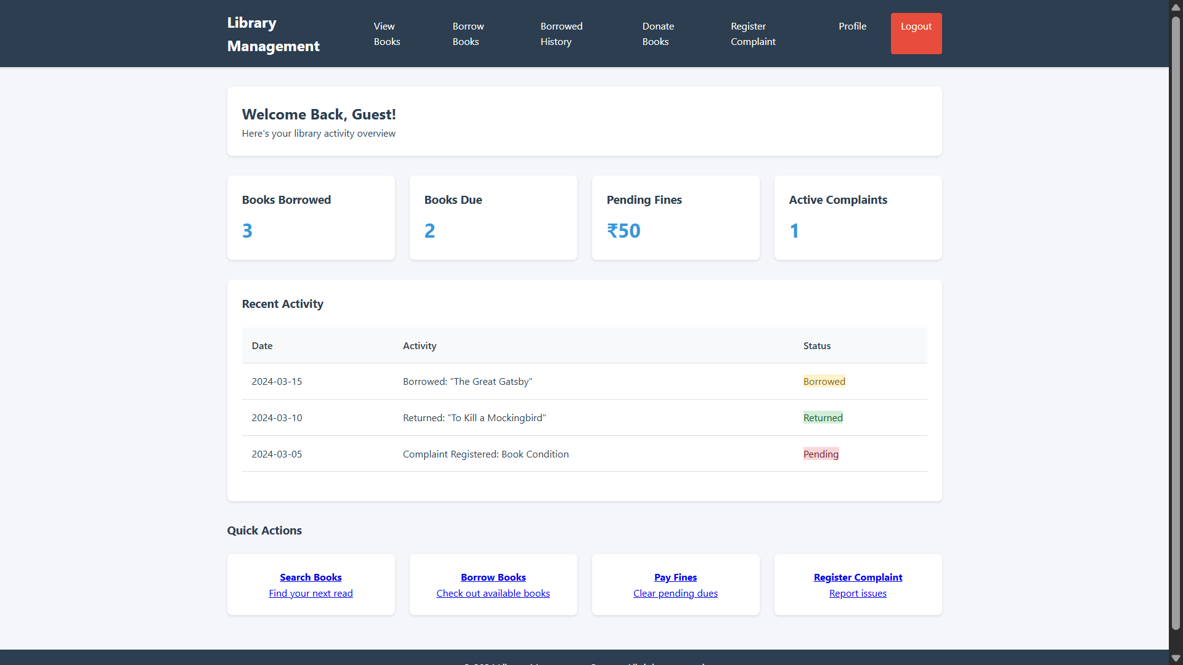

## Purpose:

This page serves as the **dashboard/homepage** for logged-in members, giving them a quick overview of their activity, statistics, and shortcuts to important actions in the library management system.

# Description:

The dashboard displays:

* + A personalized welcome message
  + Key statistics (borrowed books, due books, fines, complaints)
  + Recent activity logs
  + Quick action cards to:
* Search books
* Borrow books
* Pay fines
* Register complaints

Includes top navigation with links to:

* + Search, Borrow, Donate Books
  + Complaint registration
  + Profile update
  + Logout

# Functional Elements and JavaScript Logic:

## Dynamic Username Display:

* Retrieves the member’s name from localStorage.userData.name
* Displays it in the welcome header (#userName)

## Logout Mechanism:

* Overrides the default <a href="index.html">Logout</a> link
* Uses a JavaScript handleLogout() method (from logout.js)
* Presumably clears session data and redirects to the home/login page

## Stat Cards:

* Show counts like:
  + Books Borrowed: 3
  + Books Due: 2
  + Pending Fines: ₹50
  + Active Complaints: 1

## Recent Activity Table:

* Logs recent actions with date, description, and status badge

## Quick Actions Grid:

* Large buttons for navigation to key tasks

# Summary:

This file is the **central user interface for a logged-in library member**, aggregating real-time data and providing easy access to core functionalities. JavaScript enriches the experience with personalization and logout control.

—

# member_complaints.html

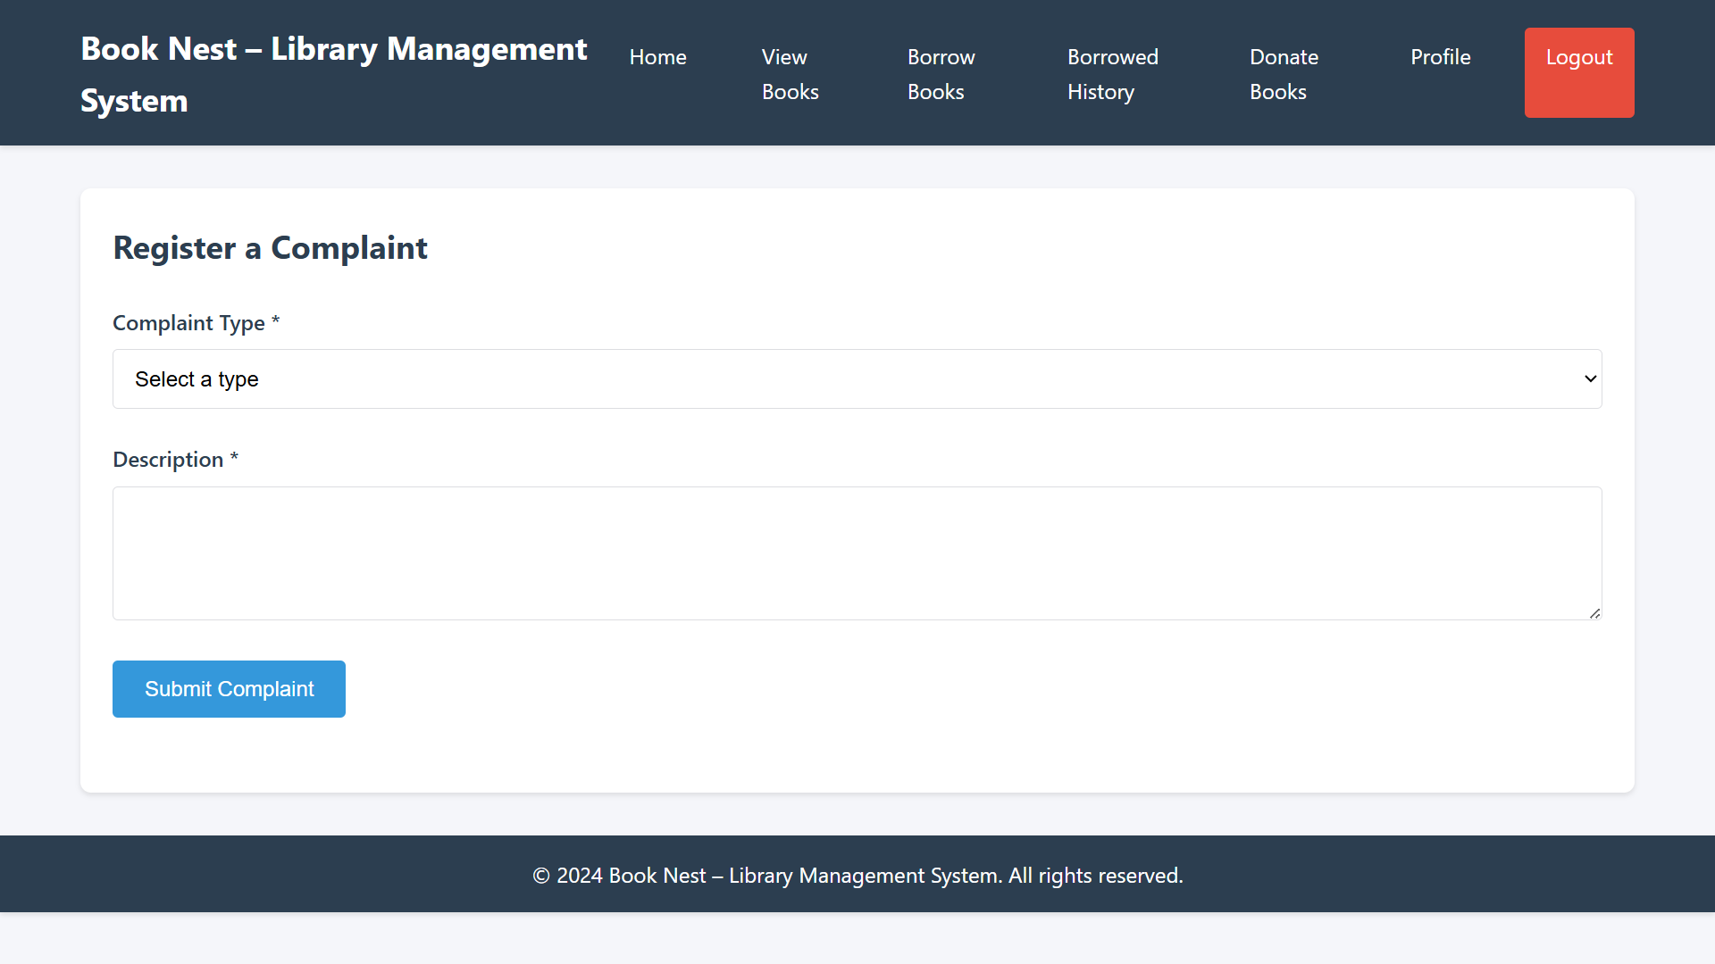

## Purpose:

This page allows a **logged-in library member** to submit a complaint regarding books, services, facilities, or other issues encountered within the library system.

# Description:

The complaint registration page contains:

* + A header with navigation to all major sections (Home, Books, History, Donate, Profile, Logout)
  + A form for submitting complaints, requiring:
* **Complaint Type** (dropdown)
* **Description** (textarea)

Once submitted, a message is shown to the user and the form is reset.

# Functional Elements and JavaScript Logic:

## Complaint Form Submission:

* HTML form with ID: complaintForm
* On submit, JavaScript prevents default form behavior.
* Displays an alert: **"Complaint submitted successfully!"**
* Resets the form afterward
* *(Note: There is no back-end logic in this file; complaint handling is assumed to be added later.)*

## Logout Functionality:

* Overrides the "Logout" link (index.html)
* Calls a handleLogout() function from the external logout.js file

# Form Fields:

|  |  |  |  |
| --- | --- | --- | --- |
| **Field Name** | **Type** | **Required** | **Details** |
| complaintType | Select | Yes | Options include Book Condition, Service Issue, Facility Problem, Other |
| complaintDescrip tion | Textare a | Yes | User inputs the issue description |

**Summary:**

This file provides a dedicated, easy-to-use complaint submission interface for library members. It ensures required inputs and provides immediate user feedback after submission, though the actual processing logic needs to be integrated with backend services.

—

# admin_page.html

## Purpose:

This page serves as the **administrator dashboard** for the Library Management System. It provides navigation and quick access to core administrative functions such as managing books, members, complaints, and reports.

# Description:

The admin page includes:

* + A top header/navigation bar with branding and key navigation links
  + A main dashboard layout featuring:
* Overview cards (e.g., total books, active members, pending complaints)
* Quick access links to management modules
* Action buttons or cards for administrative tasks

—

# borrowbook.html

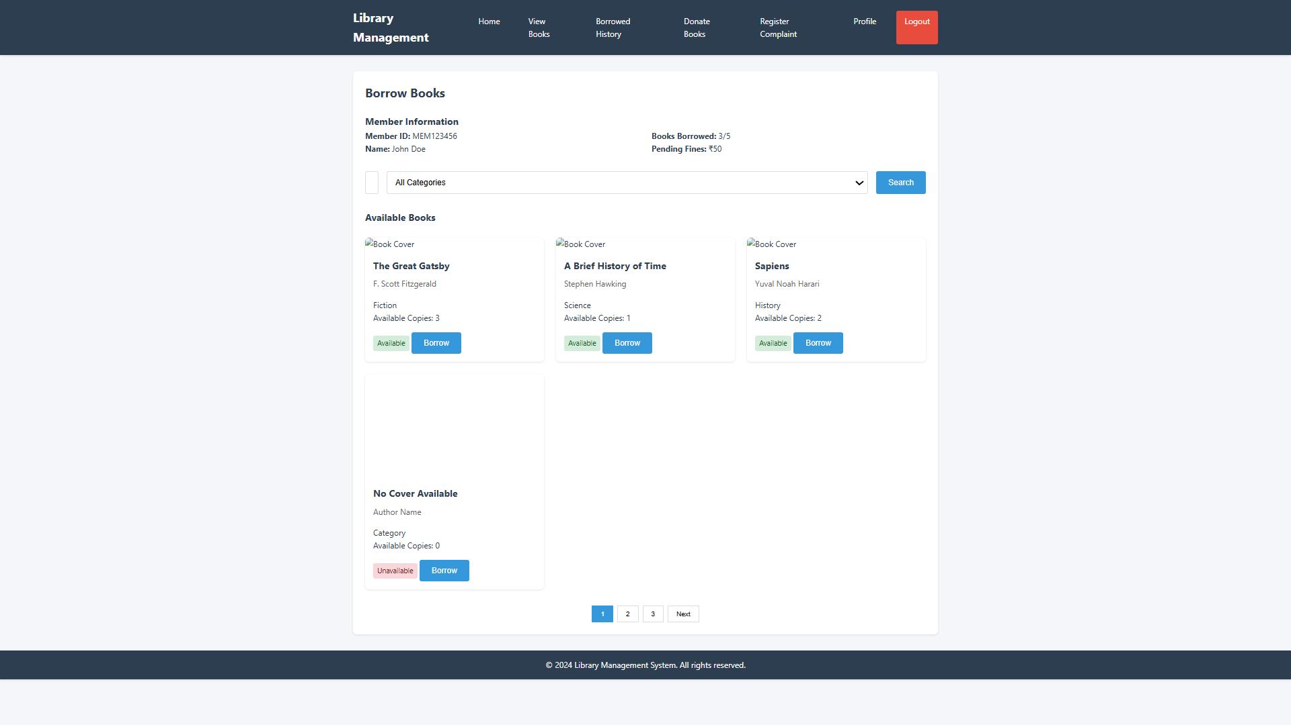

## Purpose:

This page enables library members to **search, view, and borrow books** online. It also displays borrowing limits, pending fines, and offers book borrowing confirmation via a modal popup.

# Key Features Overview:

|  |  |
| --- | --- |
| **Section** | **Description** |
| **Header Navigation** | Provides links to key member features like home, book search, donation, complaint registration, and logout. |
| **Member Info Panel** | Displays member ID, name, borrowed book count, and pending fines. |
| **Search Functionality** | Allows filtering of books by title/author and category. |

|  |  |
| --- | --- |
| **Available Books Display** | Lists books in a card layout with availability and a borrow button. |
| **Borrow Modal** | Confirms borrowing with a due date and final prompt. |
| **Pagination (Static)** | Placeholder pagination buttons for future integration. |
| **Responsive Design** | Uses grid layouts and modal styling for user-friendly UI  📄 **File: borrow_return.html**  🧩 **Purpose:**  This page provides users with a **comprehensive history of their borrowed and returned books**. It includes features such as status filtering, renewal, PDF export, and receipt download functionalities.  ✅ **Key Features Overview:**  **Section Description**  **Header** Enables access to core user actions like home,  **Navigation** book browsing, donations, complaints, profile update, and logout. |

|  |  |
| --- | --- |
| **Borrowing History Table** | Displays borrowing and return details with real-time status indicators (e.g., Borrowed, Returned, Overdue). |
| **Dynamic Filtering** | Filters history by date range and borrowing status. |
| **Actions Column** | Enables users to renew active borrows or download return receipts. |
| **No History View** | Shows a message prompting the user to start borrowing if no records exist. |
| **Export Feature** | Exports the borrowing history as a PDF for offline use.  —  **Page: donate.html**    **Purpose:**  This page allows library members to donate books to the library by submitting details about the book and tracking the status of their donation. |

## Functionality:

* **Donation Form:** Users can provide book details such as title, author, category, condition, quantity, description, and upload a book cover image.
* **Submission Handling:** On form submission, donation data is processed and a confirmation is shown (simulated via a script).
* **Donation Status Table:** Displays the user's past donations along with their status (Accepted, Pending, or Rejected) and admin responses.
* **Navigation & Logout:** Includes navigation links to other member pages and logout functionality.

**Summary**

The *Book Nest – Library Management System* is a fully functional front-end web application that offers a comprehensive digital platform for library operations. It enables members to register, log in, search and borrow books, view borrowing history, pay fines, donate books, and register complaints. Administrators can manage books, users, complaints, and donations through a dedicated interface. Built using HTML, CSS, and JavaScript, the system features intuitive navigation, real-time form validation, and modular design components. Designed for scalability and easy integration with backend systems, the project delivers a modern, user-friendly solution to traditional library management.